**To Whom It May Concern,**

This is to certify that I, the undersigned, have thoroughly reviewed and verified that all the required documents related to the project titled:

**"Early detection of Autism spectrum disorder using EEG Techniques "**

have been successfully uploaded to the designated GitHub repository.

* **GitHub Repository URL:** https://github.com/Nuha-Aamir/Autism-Detection-Tool-Using-EEG-Signal
* **Team/Student Name(s):** Nuha Aamir, Rubbaishe, Mujtaba khan
* **Department:** **Department of Computing, FEST**
* **Institution:** **Hamdard University**

The uploaded materials include (but are not limited to):

* Project source code
* Project report/documentation (Proposal/Research paper/Report/Test Report)
* Presentation slides
* Dataset(s) (if applicable)
* Poster/Video of Demo
* Link of our published review paper

I confirm that the submission complies with the documentation requirements outlined for this project/course and is accessible on the mentioned repository.

This certificate is issued for record-keeping and official use as part of the project evaluation or academic requirements.

**Supervisor Name:** Saad Akbar   
**Designation:** **Assistant Professor**

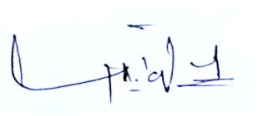

**Signature (Compulsory):**   
**Date:** **6/07/2025**